LED BLINKING USING 8051(8 BIT MC)

Learning Objectives:-

1.Coding for Led blinking

2.Using Proteus software

3.Using keil microvision software

4.Creating Hex file

5.Logic for Led Blinking

INPUTS:-

* Switch S1
* Switch S2
* Power
* Ports P0 – P7

OUTPUTS:-

* Pins are set to zero for getting the output

LOGIC:-

* When Switch 1 and Switch 2 is 0 the led will be in off
* When Switch 1 is 0 and Switch 2 is 1 the led will blink and after a delay it will blink again
* When Switch 1 is 1 and Switch 2 is 0 the led will blink and after a delay it will in off
* When Switch 1 and Switch 2 are 1 the led will blink and after delay it will be in off

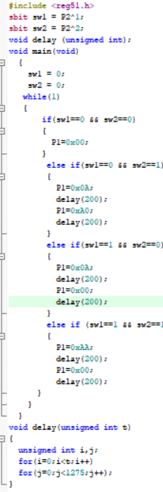

Results:-

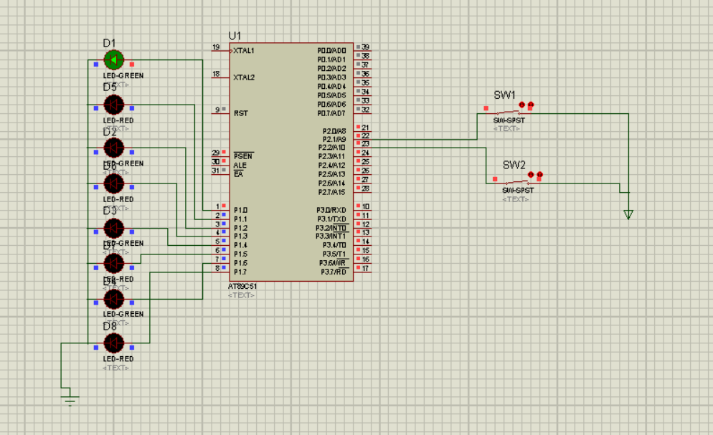

We are using a 8-bit microcontroller(8051) to make the led blink .